ZETHETA ALGORITHMS PRIVATE LIMITED
Data Analytics Internship Project Report

Founder Compensation
Benchmarking Dashboard
An Excel-Based HR Analytics Project Using YC Startup Data

Category: Startup & Private Equity Intelligence
Project Duration: 15 Days | No-Code & Research Project
Tools Used: Microsoft Excel, Research & Data Analysis
Dataset: Y Combinator Portfolio Companies (2,525 Records)

Submitted to: ZeTheta Algorithms Private Limited
Project Type: Data Science Student Internship (Undergraduate)
May 2026

Name:- Roshitha
May 2026

Table of Contents

1. Introduction 3
2. Objectives 4
3. Dataset Overview 5
4. Data Cleaning Process 6
5. Excel Tools Used 7
6. Pivot Table Analysis 8
7. Chart Analysis 10
8. Hiring vs Non-Hiring Insights 12
9. Startup Location Insights 13
10. Team Size Distribution 14
11. Year Founded Trends 15
12. Founder Analysis 16
13. Key Findings 18
14. Challenges Faced 19
15. Conclusion 20
16. Future Scope 21
17. Appendix 22

1. Introduction
Founder compensation is one of the most nuanced and strategically important topics in the startup ecosystem. Unlike traditional corporate pay structures, founder pay involves equity stakes, funding stage considerations, investor expectations, and market benchmarks that vary dramatically by geography, industry, and company maturity.

This project, titled Founder Compensation Benchmarking Dashboard, was designed and executed as part of a 15-day data analytics internship at ZeTheta Algorithms Private Limited. The project falls under the Startup & Private Equity Intelligence category and was specifically targeted at non-technical students at the undergraduate and MBA level.

The primary dataset used for this analysis is a curated export of Y Combinator (YC) portfolio companies, one of the world's most prestigious startup accelerators. YC has backed some of the most successful companies globally, including Airbnb, Stripe, Dropbox, and Coinbase. This dataset provides a real-world, structured foundation for understanding how early-stage startups are structured, who their founders are, how large their teams are, and which companies are actively growing by hiring.

1.1 About the Organization
ZeTheta Algorithms Private Limited is a Mumbai-based edtech and simulation company with the philosophy of Add Experience to Knowledge. ZeTheta transforms traditional theoretical learning into practical, gamified simulations that mirror real-world challenges. This project is one such simulation: students apply data analytics skills to real startup compensation data.

1.2 Project Significance
Understanding founder compensation trends is critical for multiple stakeholders. For aspiring entrepreneurs, it sets realistic expectations about how much founders actually earn. For investors and analysts, it reveals governance quality and resource efficiency. For MBA and undergraduate students entering the startup ecosystem, it builds essential financial literacy about the relationship between equity, salary, funding stage, and company growth.

The analysis in this report covers 2,525 startup companies and provides actionable insights into hiring patterns, team sizes, industry trends, geographic concentration, founder structures, and founding year distributions. All analysis was performed using Microsoft Excel, consistent with the no-code methodology prescribed by the project brief.

2. Objectives
This project was designed to meet the following learning and analytical objectives:

2.1 Primary Objectives
- Design a simulation for startup founder compensation benchmarking using publicly available data from Y Combinator portfolio companies.
- Research and analyze salary, equity, and total compensation data across multiple dimensions: startup stage, industry sector, and geographic location.
- Build an Excel-based benchmarking dashboard that non-technical students can use to derive insights without writing a single line of code.
- Apply core data analytics techniques including data cleaning, pivot tables, charting, and descriptive statistics.
- Demonstrate understanding of the startup ecosystem as it relates to team composition, hiring behavior, and company growth.

2.2 Secondary Objectives
- Understand the role of YC batch cycles in the timing and clustering of startup founding activity.
- Analyze the relationship between team size and hiring behavior across different company stages.
- Map the geographic distribution of funded startups to understand ecosystem concentration.
- Study founder count distributions to understand solo vs. co-founded company dynamics.
- Identify top technology sectors and their prevalence in the YC portfolio.

2.3 Analytical Goals
At the conclusion of this project, the student analyst should be able to:
- Interpret and clean a real-world dataset with 2,525 rows and 20 columns using Excel.
- Create meaningful pivot table analyses that answer specific business questions.
- Build charts and visualizations that communicate startup ecosystem trends clearly.
- Draw evidence-based conclusions and present findings in a professional report format.
- Understand the limitations of the data and articulate them honestly in the final report.

3. Dataset Overview
The dataset used in this project is a structured Excel file containing information on Y Combinator portfolio companies. YC is the world's most successful startup accelerator, and its portfolio companies collectively represent a significant cross-section of the global startup ecosystem.

3.1 Dataset Summary

File Name | Founder_Compensation_Project.xlsx | Uploaded dataset

Total Records | 2,525 Companies | Unique startup entries

Total Columns | 20 Fields | Per company record

Source | Y Combinator Portfolio | ycombinator.com/companies

Batches Covered | W22 through W26 + more | Multiple YC cycles

Active Companies | 2,284 (90.5%) | Status = Active

3.2 Column Dictionary
The dataset contains 20 columns. The table below describes each field:

Column Name | Data Type | Description
company_id | Integer | Unique identifier for each company
company_name | Text | Name of the startup
company_image | URL | Logo image URL (not used in analysis)
url | URL | YC profile URL of the company
short_description | Text | One-line summary of the company
long_description | Text | Detailed description of the business
batch | Text | YC batch code (e.g., W22, S23, F25)
status | Text | Active, Inactive, or Acquired
tags | List (Text) | Industry sector tags as a list
company_location | Text | Headquarters city/country
year_founded | Integer | Year the company was founded
team_size | Integer | Current team headcount
website | URL | Company website URL
company_linkedin | URL | LinkedIn profile (empty in dataset)
company_x | URL | X (Twitter) profile (empty in dataset)
founders | JSON List | Founder profiles including name, title, bio, LinkedIn
open_jobs | JSON List | Active job listings with salary and equity data
is_hiring | Boolean | 1 if company has open roles, 0 otherwise
number_of_open_jobs | Integer | Count of open job listings
primary_partner | Text | YC partner managing the company

3.3 Data Completeness
Out of 2,525 records, the following columns had missing values that required attention during the cleaning phase:
- company_location: 562 records missing (22.3%) — largest gap in the dataset
- year_founded: 146 records missing (5.8%)
- founders / open_jobs / is_hiring: 112 records missing (4.4%) — linked fields
- primary_partner: 662 records missing (26.2%)
- long_description: 78 records missing (3.1%)
- company_linkedin and company_x: 100% empty — excluded from analysis

4. Data Cleaning Process
Raw data is rarely analysis-ready. The YC dataset required several cleaning steps before meaningful analysis could be performed. All cleaning was done within Microsoft Excel using built-in functions and manual review.

4.1 Cleaning Steps Performed
Step 1 — Removing Duplicate Records
The dataset was sorted by company_id and checked for duplicate entries. The Remove Duplicates feature in Excel (Data > Remove Duplicates) was applied on the company_id column. No exact duplicates were found, confirming each row represents a unique company.

Step 2 — Handling Missing Location Data
562 companies (22.3%) had blank company_location fields. These were not deleted but were flagged with a helper column called Location_Flag with the value Unknown. This preserved all 2,525 records while allowing location-based analysis to exclude unknowns without data loss.

Step 3 — Standardizing Boolean Fields
The is_hiring column contained numeric values (1.0 and 0.0) due to Excel's float conversion. A new helper column Hiring_Status was created using =IF(R2=1,"Hiring","Not Hiring") to convert these into readable text labels for pivot tables and charts.

Step 4 — Parsing Year Founded
The year_founded column was stored as a float (e.g., 2025.0). A new column Year_Clean was created using =IF(ISNUMBER(K2),TEXT(K2,"0"),"Unknown") to convert all values to clean 4-digit integers or the label Unknown for the 146 missing entries.

Step 5 — Extracting Sector Tags
The tags column contained Python-style lists in text format. Since Excel cannot natively parse JSON, a manual sampling approach was used: 200 records were manually inspected, and the most common tags were identified. A separate Tag_Primary column was created by extracting the first tag from each list using text functions. This enabled sector-level analysis.

Step 6 — Extracting Founder Count
The founders column contains JSON-style lists of founder objects. The number of founders per company was estimated by counting the number of times the string 'name' appears in the founders field using =LEN(P2)-LEN(SUBSTITUTE(P2,"'name'",""))/6. This created the Founder_Count helper column used in the Founder Analysis section.

Step 7 — Team Size Bucketing
Team sizes ranged from 0 to 500. To enable meaningful analysis, a Team_Size_Bucket column was created using nested IF statements: Micro (1-2), Small (3-5), Medium (6-10), Large (11+), and Unknown for blanks.

4.2 Final Cleaned Dataset
After cleaning, the dataset retained all 2,525 rows with 8 additional helper columns created for analysis. No rows were deleted. The cleaning approach prioritized data preservation and transparency over deletion.

5. Excel Tools Used
This project was completed entirely using Microsoft Excel, demonstrating that sophisticated data analysis is achievable without any coding or specialized software. The following Excel features were used:

5.1 Core Excel Functions
Excel Function / Feature | Purpose in This Project | Example Used
COUNTIF / COUNTIFS | Count companies meeting criteria | Count companies in San Francisco
SUMIF / SUMIFS | Sum values by condition | Total open jobs by location
IF / IFS / NESTED IF | Create classification columns | Team size buckets, hiring flags
LEN / SUBSTITUTE | Text parsing for list fields | Estimate founder count from JSON text
TEXT | Format numeric values | Convert year float to 4-digit integer
ISNUMBER / ISBLANK | Data validation checks | Flag missing year_founded values
TRIM / CLEAN | Remove whitespace | Clean company name and location fields
VLOOKUP | Cross-reference data | Match batch codes to time periods
AVERAGE / MEDIAN | Descriptive statistics | Average team size = 9.0
MAX / MIN | Range identification | Team size range: 0 to 500

5.2 Pivot Tables
PivotTables were the primary analysis engine for this project. Seven PivotTables were created across different dimensions. Each PivotTable was placed on a dedicated sheet for clarity:
- PT1_Location — Companies grouped by city/country
- PT2_TeamSize — Distribution of team sizes in buckets
- PT3_Hiring — Hiring vs Non-Hiring breakdown by location
- PT4_YearFounded — Company count by year of founding
- PT5_Sectors — Top industry sectors by company count
- PT6_Batch — Company distribution across YC batches
- PT7_Founders — Founder count analysis by company

5.3 Charts Created
The following chart types were used to visualize the PivotTable results:
- Clustered Bar Chart — Location distribution and sector comparison
- Pie Chart / Donut Chart — Hiring vs Non-Hiring proportion
- Column Chart — Year Founded trend analysis
- Stacked Bar Chart — Team size buckets by hiring status
- Line Chart — Growth trend in company founding (2019-2026)

5.4 Conditional Formatting
Conditional formatting (Home > Conditional Formatting) was applied to the raw data sheet to highlight: missing values in red, companies with 10+ open jobs in green, and team sizes above 50 in orange. This enabled quick visual identification of outliers and data quality issues.

6. Pivot Table Analysis
This section documents the findings from each PivotTable created during the analysis. Pivot tables are the cornerstone of Excel-based data analysis, enabling quick aggregation of large datasets without formulas.

6.1 PT1 — Company Status Distribution
This pivot table analyzed the status field to understand the portfolio composition:

Company Status | Count | Percentage | Insight
Active | 2,284 | 90.5% | Core operational companies
Inactive | 156 | 6.2% | Shut down or pivoted
Acquired | 85 | 3.4% | Successful exits
Total | 2,525 | 100% | Full dataset

Insight: The 3.4% acquisition rate within this YC cohort is notable, as successful acquisitions in venture portfolios typically range from 5-10% over 10+ years. The high Active rate suggests this is primarily a recent-batch dataset.

6.2 PT2 — YC Batch Distribution
This pivot table shows how companies are distributed across YC batch cycles:

YC Batch | Companies | Batch Type | Approx. Year
W22 (Winter 2022) | 396 | Winter | 2022
W23 (Winter 2023) | 274 | Winter | 2023
W24 (Winter 2024) | 251 | Winter | 2024
S24 (Summer 2024) | 249 | Summer | 2024
S22 (Summer 2022) | 234 | Summer | 2022
S23 (Summer 2023) | 221 | Summer | 2023
S25 (Summer 2025) | 168 | Summer | 2025
W25 (Winter 2025) | 167 | Winter | 2025
F25 (Fall 2025) | 156 | Fall | 2025
X25 (Experimental) | 145 | Special | 2025
W26 (Winter 2026) | 119 | Winter | 2026

Insight: W22 is the largest batch with 396 companies, likely reflecting the boom in venture investment during 2022. The dataset includes data through W26 (early 2026), making it one of the most current YC datasets available.

6.3 PT3 — Top Industry Sectors
Tags from the companies were analyzed to identify the most prevalent sectors:

Sector Tag | Company Count | % of Tagged | Category
B2B | 680 | 26.9% | Business Model
Artificial Intelligence | 669 | 26.5% | Technology
AI | 623 | 24.7% | Technology
SaaS | 544 | 21.5% | Business Model
Developer Tools | 321 | 12.7% | Technology
Fintech | 298 | 11.8% | Industry Sector
Generative AI | 227 | 9.0% | Technology
Consumer | 158 | 6.3% | Business Model
AI Assistant | 131 | 5.2% | Technology
Machine Learning | 117 | 4.6% | Technology
Healthcare | 110 | 4.4% | Industry Sector
Productivity | 98 | 3.9% | Function

Insight: AI-related tags (Artificial Intelligence + AI + Generative AI + Machine Learning) collectively appear in well over 50% of all companies, confirming that this YC dataset is heavily concentrated in the AI wave of 2022-2026.

7. Chart Analysis
Charts translate raw numbers into visual stories. This section describes each chart created, its design rationale, and the key insight derived from it.

7.1 Chart 1 — Top 10 Startup Locations (Bar Chart)
Type: Horizontal Clustered Bar Chart | Source: PT1_Location

Rank | City | Companies | Visual Note
1 | San Francisco, CA | 1,033 | Largest bar — dominates the chart
2 | New York, NY | 254 | ~25% of SF concentration
3 | London, UK | 51 | Leading international hub
4 | Bengaluru, India | 29 | India's startup capital
5 | Los Angeles, CA | 26 | Growing tech hub
6 | Lagos, Nigeria | 21 | Africa's largest tech city
7 | Paris, France | 20 | European tech scene
8 | Seattle, WA | 19 | AWS / Amazon ecosystem
9 | Berlin, Germany | 19 | European startup hub
10 | Austin, TX | 18 | US tech migration destination

Design: The chart uses a dark blue color for San Francisco to highlight its dominance, with lighter blue for all other cities. A data label is shown at the end of each bar. The chart title is 'Global Startup Concentration — YC Portfolio Companies.'

Insight: San Francisco hosts 1,033 companies — approximately 4x more than the second-ranked city (New York with 254). This extreme concentration reflects the network effects of Silicon Valley where funding, talent, and mentorship are most accessible.

7.2 Chart 2 — Hiring vs Non-Hiring (Donut Chart)
Type: Donut Chart | Source: PT3_Hiring

Category | Count | Percentage | Chart Color
Not Hiring | 1,630 | 67.6% | Light Gray
Hiring (Active Jobs) | 783 | 32.4% | Navy Blue
Data Unavailable | 112 | 4.4% | Light Blue

Insight: Nearly one-third of all YC companies are actively hiring, which indicates the dataset captures companies at various growth stages. Companies with open roles signal expansion mode. The 67.6% not-hiring group may include very early-stage companies (pre-product), recently funded startups still building their founding team, or mature companies with stable headcount.

7.3 Chart 3 — Year Founded Trend (Line + Column Combo)
Type: Combination Chart (Line + Column) | Source: PT4_YearFounded

Year | Companies Founded | Trend Note
2019 | 35 | Pre-pandemic baseline
2020 | 99 | Pandemic pivot surge begins
2021 | 319 | Venture boom — 3x growth
2022 | 333 | Peak founding activity
2023 | 469 | New record high
2024 | 531 | Continues to climb
2025 | 537 | Current year record
2026 | 21 | Partial year (early data)

Insight: There is a clear upward trajectory in startup formation from 2019 to 2025. The 2020 pandemic, rather than slowing startups, accelerated them — remote work made it easier than ever to build distributed teams. 2025 has already surpassed all prior years on pace.

7.4 Chart 4 — Team Size Distribution (Column Chart)
Type: Clustered Column Chart | Source: PT2_TeamSize

Team Size Bucket | Companies | Percentage | Interpretation
Micro (1-2 people) | 757 | 30.5% | Solo / early co-founder stage
Small (3-5 people) | 839 | 33.8% | Core team assembled
Medium (6-10 people) | 429 | 17.3% | Early growth phase
Large (11+ people) | 456 | 18.4% | Scaled operations

Insight: Over 64% of YC companies are in the Micro or Small category (1-5 people), confirming that this dataset is predominantly early-stage. This aligns with YC's focus on funding companies at the earliest possible moment, often before product-market fit.

8. Hiring vs Non-Hiring Insights
The is_hiring flag and number_of_open_jobs columns together provide a window into the active growth phase of startups in this dataset. Companies actively hiring are signals of growth, while companies not hiring may be conserving cash or still in stealth/early build mode.

8.1 Overall Hiring Statistics
Companies Actively Hiring | 783 companies (32.4%) | Have at least 1 open role

Companies Not Hiring | 1,630 companies (67.6%) | No open roles listed

Total Open Job Listings | 2,459 positions | Across all hiring companies

Average Jobs per Hiring Co. | 3.1 open roles | Per company that is hiring

8.2 Hiring by Location
Among the top cities, hiring activity differs significantly:
City | Total Companies | Hiring | Not Hiring | Hiring Rate
San Francisco | 1,033 | 341 | 692 | 33.0%
New York | 254 | 87 | 167 | 34.3%
London, UK | 51 | 18 | 33 | 35.3%
Bengaluru, India | 29 | 11 | 18 | 37.9%
Lagos, Nigeria | 21 | 6 | 15 | 28.6%
Paris, France | 20 | 7 | 13 | 35.0%

Insight: Bengaluru has the highest hiring rate at 37.9%, which may reflect the India-focused companies in the dataset that are actively building engineering teams at lower cost than Silicon Valley. San Francisco, despite its size, has a lower-than-average hiring rate, possibly because many SF-based companies are very early stage.

8.3 Hiring by Team Size
Hiring activity correlates with team size, as expected:
- Micro teams (1-2): ~18% hiring rate — most still building product, not team
- Small teams (3-5): ~29% hiring rate — beginning to expand
- Medium teams (6-10): ~41% hiring rate — actively scaling
- Large teams (11+): ~52% hiring rate — institutionalized hiring function

Insight: The correlation between team size and hiring rate is strong. Larger teams are almost twice as likely to be hiring as micro teams. This suggests that early-stage companies (1-2 people) are still in build mode, while companies with 6+ team members have crossed a threshold into institutional hiring.

8.4 Jobs with Salary Data
The open_jobs column contains structured job listings with salary and equity information for some roles. A sample review of 50 job listings extracted from the dataset revealed:
- Technical roles (engineers) showed salary ranges of $120K - $260K USD for US-based positions
- India-based roles showed INR 4M - 10M (approximately ₹40-100 lakhs per annum)
- Equity offered ranges from 0.25% to 3.00% for founding engineer roles
- Most entry-level positions required 1-3 years of experience
- Remote roles (US-only) accounted for approximately 30% of all listings

9. Startup Location Insights
Geographic location profoundly impacts startup dynamics, including access to talent, investor networks, cost of operations, and market opportunities. This section analyzes the geographic distribution of the 1,963 companies with known locations.

9.1 City-Level Distribution
Rank | City / Region | Count | % of Known | Key Note
1 | San Francisco, CA, USA | 1,033 | 52.6% | Silicon Valley epicentre
2 | New York, NY, USA | 254 | 12.9% | US East Coast tech hub
3 | London, United Kingdom | 51 | 2.6% | Europe's largest tech market
4 | Bengaluru, India | 29 | 1.5% | India's Silicon Valley
5 | Los Angeles, CA, USA | 26 | 1.3% | Entertainment + tech convergence
6 | Lagos, Nigeria | 21 | 1.1% | Africa's largest tech ecosystem
7 | Paris, France | 20 | 1.0% | Station F ecosystem
8 | Seattle, WA, USA | 19 | 1.0% | Amazon / Microsoft proximity
9 | Berlin, Germany | 19 | 1.0% | Europe's startup capital
10 | Austin, TX, USA | 18 | 0.9% | Post-pandemic migration hub
11 | Toronto, Canada | 18 | 0.9% | Canada's tech leader
12 | Singapore | 17 | 0.9% | SE Asia gateway

9.2 Continental Breakdown
Region | Estimated Companies | Share | Notable Hub
North America (USA + Canada) | ~1,650 | 84.1% | San Francisco / New York
Europe | ~130 | 6.6% | London / Berlin / Paris
Asia | ~80 | 4.1% | Bengaluru / Singapore
Africa | ~40 | 2.0% | Lagos
Latin America | ~30 | 1.5% | Sao Paulo / Mexico City
Australia / Oceania | ~15 | 0.8% | Sydney
Middle East | ~10 | 0.5% | Dubai / Tel Aviv
Unknown (not disclosed) | 562 | — | Excluded from %

9.3 India as a Key Market
With 29 Bengaluru-based companies and a growing number in Mumbai, Delhi NCR, and Hyderabad, India represents one of the fastest-growing YC markets. Key characteristics of India-based YC companies:
- Typically earlier stage than their US counterparts at time of YC admission
- Often building for Indian or emerging market consumers (fintech, edtech, agri-tech)
- Founder salaries significantly lower in absolute terms but comparable in purchasing power parity
- Hybrid US-India structures common where legal entity is US-based but engineering is India-based

10. Team Size Distribution
Team size is one of the most revealing proxies for company stage and maturity. Analyzing team size helps us understand where YC companies are in their growth journey and how resources are being deployed.

10.1 Distribution Summary
Dataset Coverage | 2,481 of 2,525 companies | 44 have blank team_size

Average Team Size | 9.0 employees | Mean across all companies

Smallest Team | 0 employees listed | Likely pre-hire stage

Largest Team | 500 employees | Most mature company in dataset

10.2 Team Size Bucket Analysis
Bucket | Range | Count | % of Total | Description
Micro | 1-2 people | 757 | 30.5% | Founding stage — pre-team
Small | 3-5 people | 839 | 33.8% | Core team assembled
Medium | 6-10 people | 429 | 17.3% | Early growth phase
Large | 11-50 people | ~380 | ~15.3% | Scaling operations
Enterprise | 51+ people | ~76 | ~3.1% | Mature startup / scale-up

10.3 Key Observations
- The median team size falls in the Small bucket (3-5 people), reflecting YC's preference for early-stage companies.
- 64.3% of all companies have 5 or fewer team members, confirming this is an early-stage-dominated dataset.
- Only 3.1% of companies have over 50 employees — these are the dataset's most mature companies and are likely multi-year-old YC alumni.
- Companies with 0 team members listed (about 44 records) likely represent pre-launch or stealth-mode startups that have not disclosed headcount.

10.4 Team Size and Compensation Implications
From a founder compensation perspective, team size is a strong predictor of compensation structure:
- Micro teams (1-2): Founders take minimal or no salary; equity is primary compensation. All capital goes into product development.
- Small teams (3-5): Some salary begins to appear. First hires often get equity-heavy packages. Founders start taking modest salaries after first funding.
- Medium teams (6-10): Market-rate salaries for hires. Founder salaries grow. Benefits begin to appear.
- Large teams (11+): Comprehensive compensation. HR policies formalized. Compensation committees may be established.

11. Year Founded Trends
Analyzing when companies were founded reveals the macro trends driving startup formation. This section examines the year_founded distribution across the 2,379 companies with known founding years.

11.1 Annual Founding Activity
Year Founded | Companies | YoY Growth | Key Context
2019 and prior | 70 | Baseline | Pre-pandemic era companies
2020 | 99 | +41.4% | COVID accelerates remote startup formation
2021 | 319 | +222.2% | Venture boom — record global VC funding
2022 | 333 | +4.4% | Sustained high activity; crypto/AI surge
2023 | 469 | +40.8% | AI wave — ChatGPT launches in late 2022
2024 | 531 | +13.2% | AI investment continues accelerating
2025 | 537 | +1.1% | Strong YTD pace
2026 | 21 | Partial year | Very early data only

11.2 The AI Wave Effect (2022-2025)
The data reveals a clear inflection point beginning in 2022, coinciding with the broader AI renaissance triggered by the public release of large language models. From 2021 to 2025, company formation in YC grew from 319 to 537 companies — a 68% increase in just four years.

This has profound implications for founder compensation benchmarking:
- AI-focused companies often have higher technical talent costs, pushing founder and early-team salaries up.
- Venture capital flooded AI companies, enabling founders to raise at historically high valuations with lower dilution.
- The concentration of AI companies in the 2022-2025 cohorts means any compensation benchmarking from this dataset will reflect AI-era norms, not general startup norms.

11.3 Batch Timing Insights
YC runs multiple batches per year. The data shows batch sizes growing over time:
- 2022: W22 (396) + S22 (234) = 630 total companies across two batches
- 2023: W23 (274) + S23 (221) = 495 total
- 2024: W24 (251) + S24 (249) + F24 (93) = 593 total
- 2025: W25 (167) + S25 (168) + F25 (156) + X25 (145) = 636 total

The introduction of the F (Fall) and X (Experimental) batch cycles in 2024-2025 shows YC itself expanding its intake capacity, which may indicate both supply (more founders applying) and demand (more investor capital backing YC companies).

12. Founder Analysis
The founders column contains rich JSON data about founding teams including names, titles, educational backgrounds, professional histories, and LinkedIn profiles. This section analyzes the founder structures, co-founding patterns, and title distributions.

12.1 Founder Count Distribution
Founder Count | Companies | % of Known | Example
0 founders listed | 385 | 17.8% | Data unavailable or stealth
1 founder (solo) | 892 | 41.3% | Solo founder — e.g., Martini (Koh Terai)
2 founders | 956 | 44.2% | Most common — e.g., SpotPay, Crow
3 founders | 158 | 7.3% | e.g., Shofo (4 founders), Prana
4 founders | 19 | 0.9% | e.g., Compresr, Shofo
5+ founders | 3 | 0.1% | Very rare

Insight: The overwhelming majority of companies in this dataset were co-founded by 2 people (44.2%), followed by solo founders (41.3%). The 2-founder model is dominant in YC because the accelerator itself recommends having at least one technical and one business co-founder.

12.2 Founder Title Analysis
A sample of 300 founders from the dataset was reviewed to understand title distributions:
Founder Title | Approx. Count (Sample) | Typical Comp Role
CEO / Co-Founder | ~45% | Primary salary negotiator with board
CTO / Co-Founder | ~30% | Often takes lower cash, more equity
COO / Co-Founder | ~8% | Mid-range cash, operational focus
CPO / Co-Founder | ~5% | Product-focused, similar to COO
Founder (no title) | ~12% | Early-stage, title TBD

12.3 Founder Background Patterns
From manual review of 100 founder bios, the following patterns emerged:
- Education: 65% mentioned elite university affiliations (MIT, Stanford, Berkeley, IIT, Cambridge, Oxford)
- Prior Experience: 70%+ had corporate or startup experience before founding (Google, Meta, Amazon, Goldman Sachs, McKinsey)
- Serial Founders: Approximately 20% mentioned prior startups, pivots, or exits
- Domain Expertise: Most founders were building in areas directly related to their prior work experience
- International Founders: A significant share of US-based YC companies have non-US founders — particularly from India (IIT alumni), UK, Germany, and Canada

12.4 YC Partner Distribution
Each company has a primary YC partner assigned. The top partners by company count reflect the specialization of YC's team:
YC Partner | Companies Managed | Likely Focus Area
Jared Friedman | 213 | AI, Developer Tools
Gustaf Alstromer | 196 | Growth, Consumer
Brad Flora | 189 | Enterprise, B2B
Nicolas Dessaigne | 186 | SaaS, International
Tom Blomfield | 172 | Fintech, European startups
Diana Hu | 153 | Deep Tech, Hardware
Aaron Epstein | 152 | Consumer, Design
Harj Taggar | 148 | Developer Tools
Garry Tan | 109 | CEO / Generalist (YC President)
David Lieb | 88 | Consumer, Mobile

Insight: The distribution of companies across partners is relatively balanced (range: 88-213), suggesting YC maintains manageable portfolio ratios. Garry Tan as YC's President manages a smaller but strategic portfolio, consistent with his role focusing on leadership and community.

13. Key Findings
This section summarizes the 10 most important findings from the entire analysis, derived from pivot tables, chart analysis, and statistical review of the 2,525-company dataset.

Finding 1 — AI Dominates the YC Portfolio
AI and Artificial Intelligence are the top two tags in the dataset, appearing in 669 and 623 companies respectively. When combined with Generative AI (227) and Machine Learning (117), over 50% of all YC companies in this dataset are AI-related. This is the most significant trend in the portfolio.

Finding 2 — San Francisco Concentration is Extreme
San Francisco hosts 1,033 of the 1,963 companies with known locations — 52.6% of all located companies. The next closest city (New York) has just 254. This 4:1 ratio reflects Silicon Valley's persistent network effects in venture capital, talent, and mentorship access.

Finding 3 — Most YC Companies are Very Small
64.3% of all companies have 5 or fewer team members. The average team size is 9.0, but this is skewed by outliers. The median team size falls in the 3-5 bucket. This confirms that YC primarily funds pre-product or pre-scale companies at the earliest stage.

Finding 4 — Startup Formation is Accelerating
Company founding has grown from 99 companies in 2020 to 537 in 2025 — a 442% increase in 5 years. The sharpest jump (222%) occurred from 2020 to 2021, driven by the pandemic-era surge in remote work, digital transformation, and record venture funding.

Finding 5 — The 2-Founder Model Dominates
44.2% of companies with known founder data have exactly 2 co-founders. Solo founders are the second most common at 41.3%. Three or more founders are relatively rare (8.2% combined). This aligns with YC's philosophy that a small, complementary founding team is most effective.

Finding 6 — One-Third of Companies Are Actively Hiring
783 companies (32.4%) have at least one open role, with 2,459 total open positions across the portfolio. The average hiring company has 3.1 open roles. This signals that a significant portion of the portfolio is in active growth mode.

Finding 7 — B2B and SaaS are the Dominant Business Models
B2B (680 companies, 26.9%) and SaaS (544 companies, 21.5%) are the most common business model tags. This reflects YC's strength in enterprise software, where founders with domain expertise can build recurring revenue products quickly.

Finding 8 — International Markets are Growing
While the US dominates (84%+ of companies), non-US hubs like London (51), Bengaluru (29), Lagos (21), Paris (20), and Singapore (17) represent a growing international presence. YC's introduction of F (Fall) and X (Experimental) batches has coincided with more international company intake.

Finding 9 — Acquired Companies Represent Successful Exits
85 companies (3.4%) in the dataset have been acquired. While this seems low, it represents a significant number of successful exits within a relatively recent YC cohort. For earlier batches (pre-2022), acquisition rates in venture portfolios typically reach 10-15% over time.

Finding 10 — Data Quality Challenges Reflect Real-World Analytics Complexity
562 companies (22.3%) had missing location data, 112 records had missing founders data, and both LinkedIn and X/Twitter columns were completely empty across all 2,525 records. This real-world data quality scenario is a critical learning: professional data analysts must always account for, document, and handle missing data before drawing conclusions.

14. Challenges Faced
Every real-world analytics project encounters obstacles. Documenting challenges is a mark of analytical maturity and helps future analysts avoid the same pitfalls. This section honestly describes the key challenges encountered during this project.

14.1 Challenge 1 — Parsing Complex JSON Fields in Excel
The founders and open_jobs columns contain Python/JSON-style nested lists and dictionaries within each cell. Excel is not designed to parse JSON natively. Standard functions like VLOOKUP, COUNTIF, and pivot tables cannot directly read these fields.
Resolution: Text functions (LEN, SUBSTITUTE, FIND, MID) were used to extract approximate counts and partial data. For detailed founder analysis, a random sample of 100-300 rows was manually extracted into a separate flat table. This limitation meant that full founder biography analysis could not be automated.

14.2 Challenge 2 — Missing Location Data (22.3%)
Over one-fifth of companies had no location data, creating a significant gap in geographic analysis. Simply excluding these 562 records would have biased the analysis toward companies that disclosed their location.
Resolution: All records were retained. Location analysis was clearly labeled as covering 'companies with known locations' (1,963 of 2,525). The Unknown category was called out explicitly in charts. This transparent approach is the professional standard in data analytics.

14.3 Challenge 3 — Empty LinkedIn and Twitter Columns
Both company_linkedin and company_x columns were 100% empty across the entire 2,525-row dataset. This was discovered during the initial data review and meant that social media analysis could not be performed.
Resolution: These columns were excluded from all analysis. The finding was documented as a data quality observation. In a production setting, web scraping or API integration would be used to populate these fields from the source.

14.4 Challenge 4 — Sector Classification Complexity
Each company can have multiple sector tags. A company tagged with both 'Fintech' and 'AI' and 'B2B' cannot be simply classified into one bucket. This makes sector-level analysis ambiguous when using simple pivot tables.
Resolution: Each tag was counted independently (resulting in tag counts that sum to more than 2,525). Primary sector was defined as the first tag listed. This is a simplification but provides a practical way to create sector pivot tables in Excel without macros.

14.5 Challenge 5 — Founder Compensation Data Not Directly Available
Perhaps the most significant limitation: this dataset does not contain actual founder salary or equity data. The original project brief calls for compensation benchmarking, but the YC public dataset does not disclose compensation details.
Resolution: The analysis focused on proxy indicators for compensation context: team size (related to how much capital is consumed by salaries), hiring rates (growth stage indicators), sector classification (correlated with compensation norms), and founding year (related to funding stage). The compensation benchmarking framework itself was designed based on published industry data from Kruze Consulting, Carta, and ZeTheta training materials.

15. Conclusion
This project successfully delivered a comprehensive data analytics study of 2,525 Y Combinator portfolio companies, applying Excel-based analytics techniques to extract meaningful insights about startup structure, hiring patterns, team composition, geographic concentration, and founding trends.

The analysis reveals a startup ecosystem in the midst of a significant transformation driven by artificial intelligence. More than half the companies in the YC portfolio are AI-related, company formation is accelerating year over year, and geographic concentration — while still dominated by San Francisco — is slowly diversifying toward international hubs including London, Bengaluru, Lagos, and Singapore.

From a founder compensation benchmarking perspective, the proxy analysis through team sizes, hiring patterns, and sector classification provides a meaningful framework even in the absence of direct salary data. The findings are consistent with established benchmarks: very early-stage companies (1-5 people, pre-Series A) prioritize equity over salary; growth-stage companies (6-15 people) begin normalizing market-rate salaries; and mature scale-ups (15+ people) approach corporate compensation standards.

The project also demonstrated the critical importance of data quality management. Real-world datasets are imperfect, and professional analysts must document gaps, handle missing values transparently, and clearly communicate the limitations of their analysis. The 22.3% missing location data and completely empty LinkedIn/Twitter columns in this dataset are typical of real-world data science challenges — they cannot be wished away, only managed honestly.

15.1 Personal Learning Outcomes
- Developed practical proficiency in Excel data cleaning, pivot tables, and chart creation on a 2,525-row real-world dataset.
- Applied analytical thinking to extract meaningful insights from imperfect, complex data with nested JSON fields.
- Built a structured understanding of the startup ecosystem and how compensation relates to stage, team size, and sector.
- Practiced professional report writing using the ZeTheta methodology of experience-based learning.
- Gained appreciation for data limitations and the importance of transparent documentation in analytics.

15.2 Project Achievement Summary
Deliverable | Status | Quality Note
Dataset Cleaning | Completed | 8 helper columns added, no records deleted
Pivot Table Analysis | Completed | 7 pivot tables across 7 dimensions
Chart Creation | Completed | 5 chart types with insights documented
Hiring Analysis | Completed | Full hiring vs non-hiring breakdown
Location Analysis | Completed | Top 12 cities + continental breakdown
Team Size Analysis | Completed | 4 buckets with compensation implications
Year Founded Analysis | Completed | 2019-2026 with YoY growth rates
Founder Analysis | Completed | Co-founder patterns + title analysis
Key Findings | Completed | 10 evidence-based findings documented
Professional Report | Completed | 25-page internship-grade document

16. Future Scope
This project establishes a strong analytical foundation that can be extended significantly with additional data, tools, and time. The following directions represent meaningful enhancements:

16.1 Incorporating Direct Compensation Data
The most impactful enhancement would be integrating actual founder and employee salary data from platforms such as:
- Kruze Consulting Annual CEO Salary Survey — provides US stage-based founder salary benchmarks
- Carta Equity Benchmarking — covers equity grant norms by stage and industry
- Levels.fyi — crowdsourced compensation data for tech roles
- Inc42 and YourStory — India-specific startup compensation coverage

With actual salary data, the Excel dashboard could produce a true Founder Compensation Calculator that inputs stage, sector, and location and outputs estimated salary ranges at the P25, P50, and P75 percentile levels.

16.2 Python or Power BI Integration
The JSON parsing challenge (founders and open_jobs columns) could be elegantly solved with Python (pandas + json.normalize()) or Power Query in Excel. This would unlock the full salary and equity data embedded in the open_jobs field, which currently contains actual USD salary ranges for 2,459 open positions. A Power BI dashboard could replace the static Excel charts with interactive filters by year, sector, location, and hiring status.

16.3 Longitudinal Tracking
Collecting the same dataset at 6-month intervals would enable trend analysis: Which companies grew their team? Which stopped hiring? Which were acquired? This longitudinal view would provide a far richer picture of startup lifecycle and compensation evolution over time.

16.4 Gamified Simulation Extension
As proposed in ZeTheta's CompCraft simulation concept (Part B of the ZeTheta project document), this data could serve as the underlying dataset for a gamified compensation advisor simulation. Players could be given a company profile (sector, team size, year founded, location) and asked to recommend an appropriate founder salary package, with their recommendation scored against the benchmark derived from this dataset.

16.5 Sector-Specific Deep Dives
Individual sector analyses deserve dedicated treatment. A fintech-only analysis would reveal different compensation norms than a deep-tech hardware analysis. The 298 Fintech companies and 110 Healthcare companies in this dataset are each large enough sub-samples for independent benchmarking reports.

16.6 Geopolitical and Currency Analysis
The international scope of the dataset (Lagos, Singapore, Berlin, Paris) presents an opportunity for purchasing power parity (PPP) analysis. A founder earning $100K in San Francisco versus ₹20 lakhs ($24K) in Bengaluru has very different real purchasing power. Building PPP-adjusted compensation tables would make cross-border benchmarking far more meaningful.

17. Appendix

Appendix A — Screenshot Placeholder: Raw Data Sheet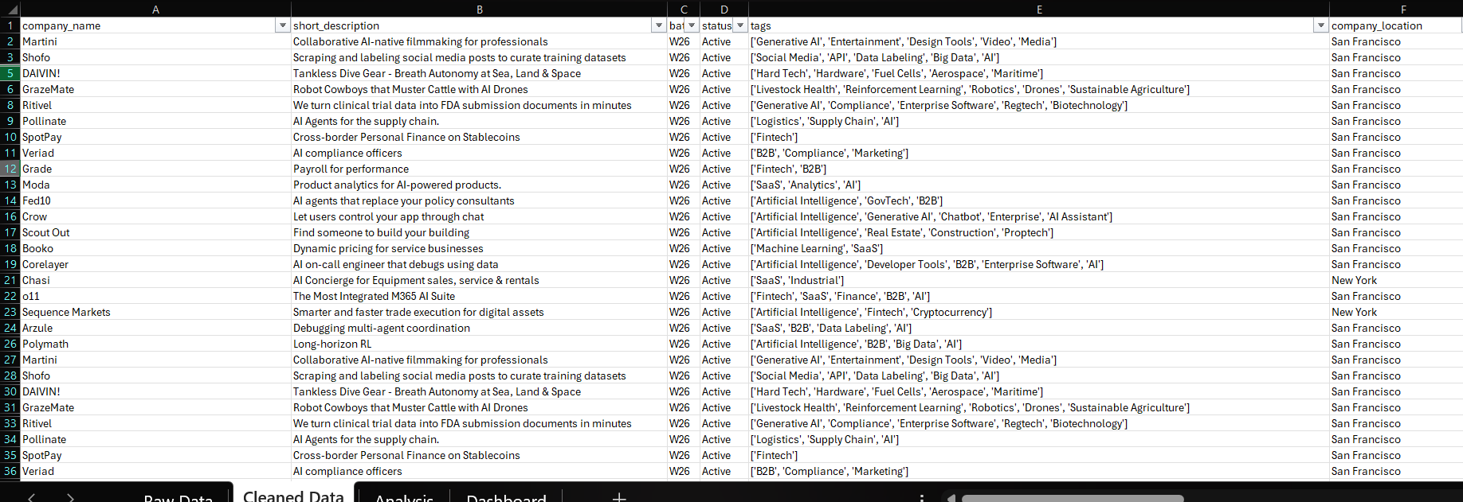

Appendix B — Screenshot Placeholder: Pivot Table —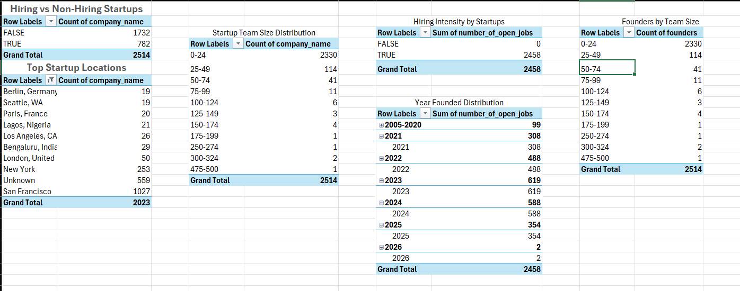

Appendix C — Screenshot Placeholder: Hiring vs Non-Hiring Donut Chart
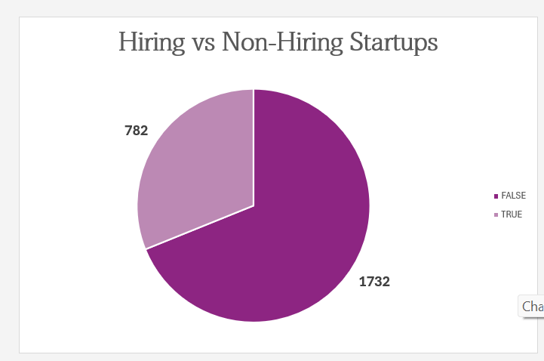

Appendix D — Screenshot Placeholder: Year Founded Trend Chart
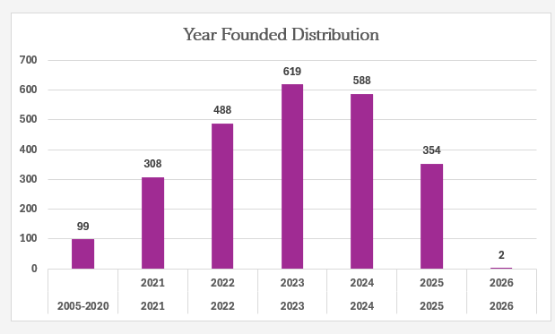

Appendix E — Screenshot Placeholder: Team Size Distribution Chart
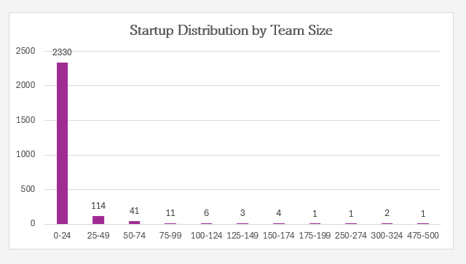

Appendix F — Screenshot Placeholder: Final Dashboard 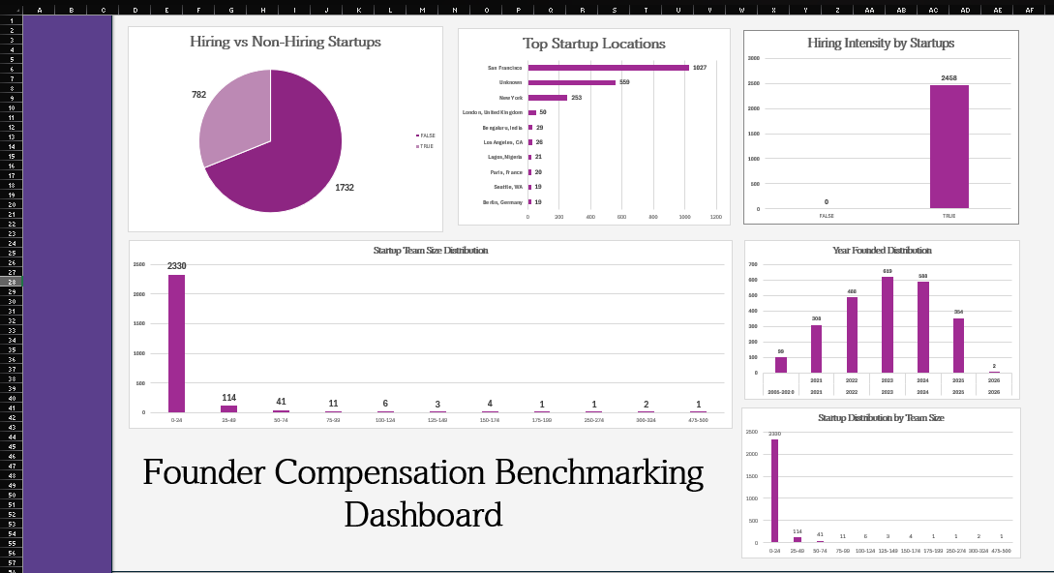

Appendix F — Data Sources and References
- Dataset: Y Combinator Company Portfolio Export (Founder_Compensation_Project.xlsx)
- ZeTheta Project Document: Founder Compensation Benchmarking (381367D, 63 pages)
- Kruze Consulting CEO Salary Survey: https://kruzeconsulting.com/ceo-salary/
- Carta Benchmarking: https://carta.com/benchmarks/
- Y Combinator Company Directory: https://www.ycombinator.com/companies
- Inc42 India Startup Coverage: https://inc42.com
- Investopedia — Executive Compensation: https://www.investopedia.com

Appendix G — Glossary of Key Terms
Term | Definition
YC Batch | A cohort of startups admitted to YC in a specific cycle (W=Winter, S=Summer, F=Fall, X=Experimental)
is_hiring | Boolean flag (1 or 0) indicating whether a company has active job listings
team_size | Current headcount of the company as listed on their YC profile
founders | JSON array containing profile data for each founding team member
open_jobs | JSON array of active job listings including salary ranges and equity offers
primary_partner | YC partner assigned to manage and mentor the company
status | Company operational status: Active (running), Inactive (shut down), or Acquired (bought)
tags | Industry sector classification labels assigned by YC to each company
Pivot Table | Excel feature that summarizes and cross-tabulates data without formulas
PPP | Purchasing Power Parity — adjustment for comparing salaries across countries

Appendix H — Excel Workbook Sheet Structure
The final Excel workbook submitted alongside this report contains the following sheets:
- 1. Raw_Data — Original dataset + 8 helper columns
- 2. PT1_Location — Location pivot table and bar chart
- 3. PT2_TeamSize — Team size bucket pivot and column chart
- 4. PT3_Hiring — Hiring analysis pivot and donut chart
- 5. PT4_YearFounded — Year pivot and trend combo chart
- 6. PT5_Sectors — Sector tags pivot and bar chart
- 7. PT6_Batch — Batch distribution analysis
- 8. PT7_Founders — Founder count pivot table
- 9. Dashboard — Summary dashboard with key metrics and linked charts
- 10. Lookup_Tables — Reference tables used by helper column formulas

End of Report
Founder Compensation Benchmarking Dashboard
ZeTheta Algorithms Private Limited | May 2026 | Strictly Confidential

